
Pupil premium strategy statement

This statement details our school’s use of pupil premium funding to help improve the attainment of our disadvantaged pupils.
It outlines our pupil premium strategy, how we intend to spend the funding in this academic year and the outcomes for disadvantaged pupils last academic year.

School overview
Detail | Data
Number of pupils in school | 431
Proportion (%) of pupil premium eligible pupils | 36.5%
1 | 2025-2026
Date this statement was published | November 2025
Date on which it will be reviewed | July 2026
Statement authorised by | L Christensen
Pupil premium lead | L Christensen
Governor / Trustee lead | Rob Osbourn

Funding overview
Detail | Amount
Pupil premium funding allocation this academic year | £ 227,845.00
Total budget for this academic year | £ 2,381,888

Part A: Pupil premium strategy plan

Statement of intent
Our Vision
Stokes Wood Primary School is an ambitious place. We aim to help every child become a global ambassador, ready to explore and understand the world around them. We encourage our children to be curious, ask questions and seek answers as they learn. Our children are confident in sharing their ideas and opinions. They know how to listen and communicate with kindness and respect. We believe in a community where there are no outsiders– everyone belongs and every voice is heard. Above all, we nurture their well-being, ensuring they grow into healthy, balanced individuals committed to lifelong learning and positive change. Together, we create a caring and supportive environment where everyone can grow and succeed, ready to make a positive difference in Leicester and beyond!
At our school, we are deeply committed to ensuring that all children—regardless of their background, ethnicity, individual needs, or home language—make strong progress and achieve high levels of attainment across all subject areas.
A central focus of our Pupil Premium (PP) strategy is to ensure that disadvantaged pupils are supported to reach their full potential. This includes enabling progress for pupils who are already high attainers. We take a holistic approach, recognising that vulnerable pupils, such as those with a social worker or who act as young carers, may face additional barriers. The initiatives we have outlined aim to support these pupils, irrespective of whether they qualify as disadvantaged under PP criteria.
High-quality teaching remains at the heart of our strategy. We prioritise areas where disadvantaged pupils need the most support, in line with evidence that this approach has the greatest impact on narrowing the attainment gap. Importantly, this strategy benefits all pupils, ensuring that non-disadvantaged learners also sustain and improve their attainment.
Our approach is informed by rigorous diagnostic assessments, allowing us to respond effectively to both common challenges and individual needs. We avoid assumptions about the impact of disadvantage and instead base interventions on clear, contextual understanding.
- To ensure the success of our strategy, we are committed to the following actions:
- Challenging disadvantaged pupils through ambitious, well-structured learning opportunities.
- Identifying needs early and intervening promptly to offer targeted support.
- Embedding a whole-school approach where all staff are accountable for the outcomes of disadvantaged pupils and maintain high expectations of what every child can achieve.
- To close the gap between the attainment of disadvantaged and non-disadvantaged pupils across the school by accelerating the progress of disadvantages pupils.
- This inclusive and proactive approach underpins our belief that every child, regardless of circumstance, deserves the opportunity to succeed.

Challenges
This details the key challenges to achievement that we have identified among our disadvantaged pupils.
Challenge number | Detail of challenge
1 | Children’s limited spoken language skills, regardless of their first language, affect their written communication. This is largely due to reduced exposure to rich language experiences, especially through books and reading.
2 | Good attendance at school is not a priority or valued for many of our families.
3 | Several disadvantaged pupils face social, emotional, and mental health needs that hinder both their learning and well-being. Additional medical or developmental needs, such as ASD, ADHD, and hearing impairments, further compound these barriers, underscoring the need for tailored support and early intervention.
4 | Some pupils from families just above the Pupil Premium threshold face comparable or greater disadvantages than eligible peers. Limited parental capacity due to long working hours highlights the need for inclusive, needs-based support beyond funding criteria.
5 | Limited life experiences means that some children struggle to access texts and relate to the wider curriculum.

Intended outcomes
This explains the outcomes we are aiming for by the end of our current strategy plan, and how we will measure whether they have been achieved.
Intended outcome | Success criteria
Improved communication, oracy and reading skills leading to children’s increased ability to write fluently and creatively. | Increased PP children achieving ARE. In-school gaps narrowing still further
All children and their families value good attendance so that little learning is lost. | Improve PP children’s attendance and reduce persistent absenteeism  - the percentage of all pupils who are persistently absent being below X% and the figure among disadvantaged pupils being no more than X% lower than their peers.
Improved engagement and behaviour in lessons, enabling greater access to learning and improved academic progress. | Identified pupils with SEMH, medical, or developmental needs will show improved lesson engagement, measured through observation logs and a reduction in behaviour incidents
More parents actively engage in their children’s learning and share the school’s high aspiration for their children. | PP children attaining in line with national benchmarks Children and parents are ambitious for academic success and are considering future options
All children have equal access to a wider range of life experiences. | PP children attaining in line with national benchmarks PP children are articulate and can make meaningful links between learning experiences  - qualitative data from student voice, student and parent surveys and teacher observations  - a significant increase in participation in enrichment activities, particularly among disadvantaged pupils

Activity in this academic year
This details how we intend to spend our pupil premium funding this academic year to address the challenges listed above.

Teaching (for example, CPD, recruitment and retention)
Budgeted cost: £ 45,690.42
Activity | Evidence that supports this approach | Challenge number(s) addressed
Professional development to support implementation of approaches, for example, training throughout the year for staff on ALS phonics programme, mastery based approaches to teaching in Maths. | Phonics approaches have a strong evidence base that indicates a positive impact on the accuracy of word reading, particularly for disadvantaged pupils:  Phonics EEF  The DfE non-statutory guidance has been produced in conjunction with the National Centre for Excellence in the Teaching of Mathematics, drawing on evidence-based approaches:  DFE Mathematics guidance KS1 and 2 | 1, 5
Technology and other resources that support high-quality teaching – Purchase of LYFTA platform and using it to develop oracy programme and implement Lyfta time oracy assemblies and Accelerated Reader to support diagnostic assessment together with the purchase of online Collins books to support fluency reading interventions at KS2. | There is a strong evidence base that suggests oral language interventions, including dialogic activities such as high-quality classroom discussion, are inexpensive to implement with high impacts on reading:  Oral Language Interventions EEF  When used effectively, diagnostic assessments can indicate areas for development for individual pupils, or across classes and year groups:  Diagnostic Assessment EEF | 1, 5
Supporting the recruitment and retention of teaching staff, by providing cover time to undertake professional development such as National Professional Qualifications (NPQs) | Evidence shows that strong outcomes for pupils is directly linked to teacher quality.  Teacher quality, recruitment and retention | 1, 3

Targeted academic support (for example, tutoring, one-to-one support, structured interventions)
Budgeted cost: £ 162,033.70
Activity | Evidence that supports this approach | Challenge number(s) addressed
One to one and small group tuition delivered by Level 3 trained TAs in BRP and phonics | Tuition targeted at specific needs and knowledge gaps can be an effective method to support low attaining pupils or those falling behind:  One to One tuition EEF  Phonics approaches have a strong evidence base indicating a positive impact on pupils, particularly from disadvantaged backgrounds. Targeted phonics interventions have been shown to be more effective when delivered as regular sessions over a period up to 12 weeks:  Phonics EEF | 1, 3
Targeted interventions and resources to meet the specific needs of disadvantaged pupils with SEND delivered by pastoral team to include ELSA, Bio-Feedback and SALT and Nurture which includes Big Moves and Fine and Gross Motor skills. | There is extensive evidence associating childhood social and emotional skills with improved outcomes at school and in later life (e.g., improved academic performance, attitudes, behaviour and relationships with peers):  Improving Social and Emotional Learning in Primary Schools EEF | 3
Extended school time offered to include Phonics, Reading and Maths clubs as well as Easter holiday academic support sessions for Year 6. | Tuition targeted at specific needs and knowledge gaps can be an effective method to support low attaining pupils or those falling behind:  Small group tuition EEF | 2, 4, 5

Wider strategies (for example, related to attendance, behaviour, wellbeing)
Budgeted cost: £ 20,121.30
Activity | Evidence that supports this approach | Challenge number(s) addressed
Attendance Officer 2 day/wk to reduce persistent absenteeism amongst PP pupils by 5% and communicate with and support parents. | Approaches to support attendance are outlined in the Working Together to Improve School Attendance and in the Attendance Toolkit.  The EEF has produced a supporting school attendance resource structured around six evidence-informed themes to support school leaders and attendance teams.  Supporting School Attendance EEF  EEF evidence suggests that school use of attendance and family liaison officers, integrates with other attendance strategies can lead to effective improvement in pupil attendance. | 2, 4
Free breakfast club & ‘booster’ provision for up to 12 PP children whose attendance is of concern | Incentive to improve attendance and punctuality  Breakfast Clubs and attendance in areas of high depravity | 2, 3, 4
Extra-curricular activities, including sport, outdoor activities, arts and culture, for example providing music lessons with Rock Steady and school trips | Evidence shows that direct support for families facing barriers leads to greater engagement with school, better attendance and improved readiness to learn  EEF toolkit Working with Parents shows that parental engagement leads to positive impact on children's attainment.  EEF evidence Toolkit shows the benefits of physical activity and Music for core academic attainment particularly literacy and mathematics as well as health and wellbeing.  Physical Activity EEF  First Thing Music EEF | 2, 3, 4, 5
Support PP families through purchase of school uniform and school PE T-shirts | Evidence shows that Wider experiences have led to a more creative input in learning. Improved standards of writing  Financial Help with School Uniforms | WellChild | 2, 4

Total budgeted cost: £ 227,845.00

Part B: Review of the previous academic year

Outcomes for disadvantaged pupils
Aim | Outcome
Teaching
Whilst individual strategies can be evidenced as successful in accelerating progress and supporting children to catch up, gaps have widened this year in terms of age-related expectations at the end of KS2 for disadvantaged pupils. Narrowing these gaps once again is a high priority for the school in 2025/26.
Additional Y6 teacher to support pupils and release Y6 teachers. Teacher (2 days a week) to release subject leaders to support improvements in teaching and learning across the school in reading and writing as well as foundation subjects, which will include lesson observations, focus on pupil progress, pupil and teacher interviews.  TAs employed to deliver academic coaching at lunchtimes in Y6 and in after school maths and reading clubs.  Additional teacher and teaching assistants to deliver a range of interventions to close the gaps in learning for disadvantaged pupils in EYFS and KS1, including phonics interventions and Fun Time to develop language.  TAs employed in the afternoons to support phonics and reading in Y1 (evidence-based phonics and BRP interventions).  Successful strategies | 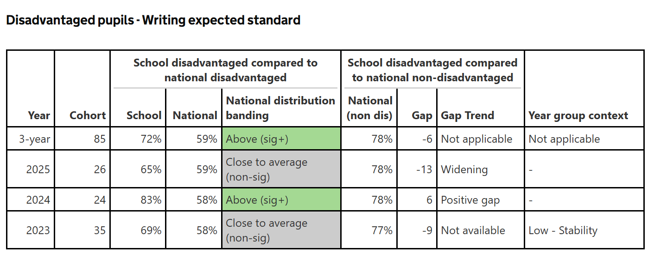  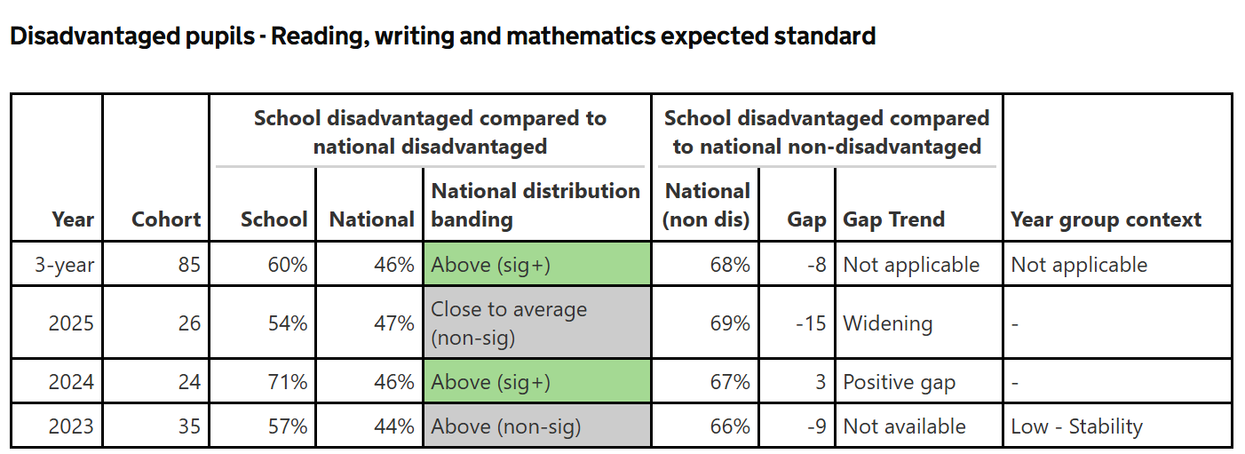  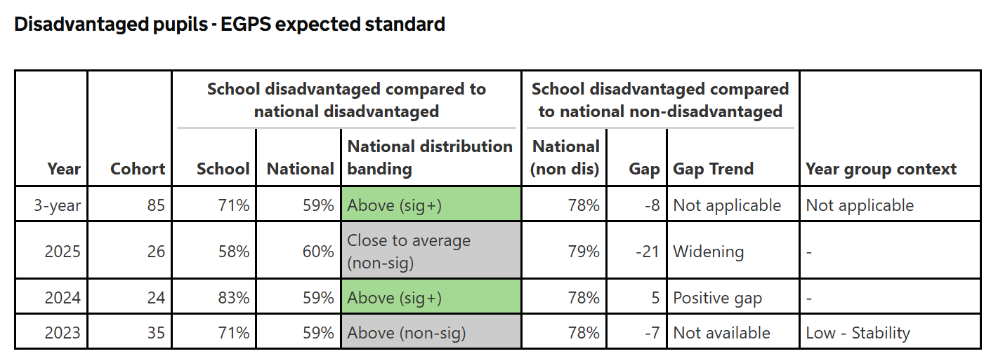  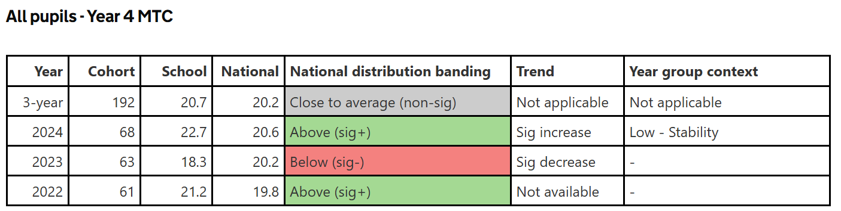  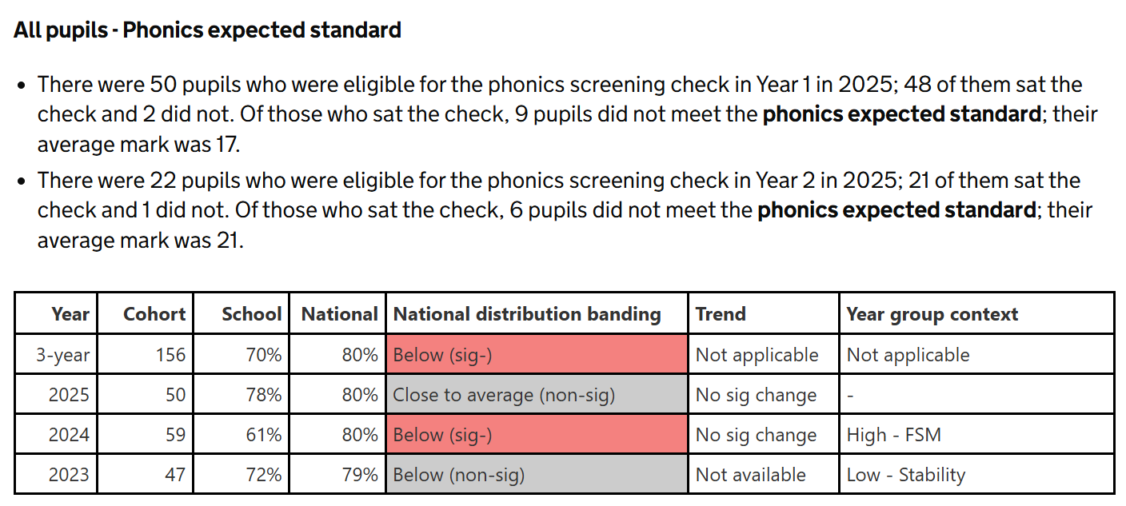

Ongoing employment since Sept 2011 of a Learning Behaviour Mentor to support disadvantaged pupils and other vulnerable pupils and their families. 2 additional TAs and learning behaviour mentor to support academic coaching in Y6 for disadvantaged pupils. 4 additional TAs to support disadvantaged/vulnerable pupils across KS1 and Y3-5. AHT for Pastoral support of pupils and their families. Appointment of an apprentice Emotional Health Practitioner who works with parents and identified children. | Successful strategy that has improved the wellbeing, behaviour and resilience of children in the classroom. Staff and pupil voice suggests higher levels of wellbeing.  Mental Health intervention with Y6 pupil was a successful strategy – they were able to take their SATS and achieved ARE in Maths.  AHT has made a significant difference to pupils and their families and developed systems and processes within school to support wellbeing.
Nurture group staffing to support vulnerable/disadvantaged pupils and those falling behind in KS1.  Nurture group staffing also address the emotional needs of Y1 and Y2 pupils who find a whole day in the classroom difficult.  Provision mapping software tracks progress of pupils in interventions. Additional part time teacher ( 2 days) to release subject leaders to monitor all aspects of the curriculum (planning, delivery, skill progression and impact on pupil outcomes). | 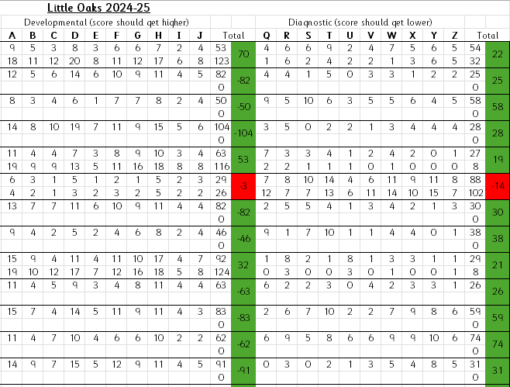  Successful strategy. 92.3% of children made rapid progress in this intervention.  This year, interventions have been carried out across the school to support children with SEND who receive Pupil Premium funding across the four broad areas of need. These interventions have been recorded and progress tracked on Edukey. 85 focused interventions took place across the year and most pupils made rapid progress, some made expected progress and some children made small steps progress against their starting points. Regular reviews help ensure that pupils only continue with an intervention if it is having a positive impact on their progress. Where it is not, other strategies or interventions are applied. This is a successful strategy.
Designated member of staff to promote reading, be a reading role model, attend CPD, run the library, talk with children about book selection, track progress and reading miles and maintain a quality selection of books. | Successful strategy.
Designated member of staff to support pupils with significant EAL, new arrivals to the UK, attends CPD, liaises and supports class teachers, deliver daily interventions. | Successful strategy – additional use of learning platforms to support children’s learning and reintegration into the classroom has been successful. 9 children worked with, 5 were reintegrated into full time learning and made accelerated progress through the EAL stages of learning.
Targeted Academic Support
After school targeted reading clubs led by class teacher in Y6. | 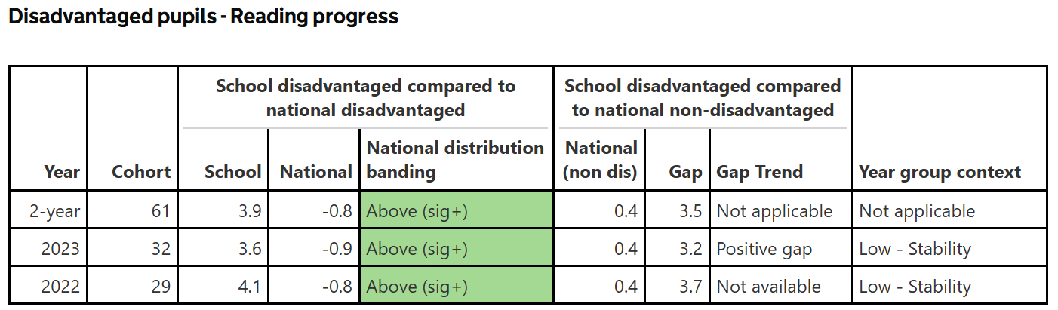  Successful Strategy. All children made accelerated progress in fluency to close the gap. 2 children achieved 99 as a scaled score in SATs.
After school maths targeted club Y4. | 68% or 11/16 PP in Year 4 achieved expected standards compared to non-disadvantaged where 54% or 31/57 achieved expected standards or above – Successful strategy
Y6 1 to 1 support during lunchtime and before school in Y6 | Child was at risk of permeant exclusion. Attendance improved and child achieved EXP (M) and WTS ( R/W). -Successful Strategy
Wider strategies
Daily walking bus: 2 members of staff who collect disadvantaged pupils whose attendance/ punctuality is poor or their start to the day at home means they arrive unsettled at school | 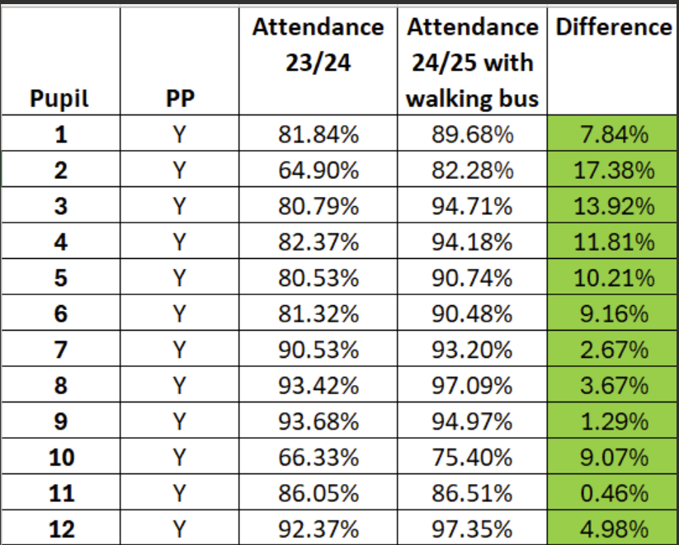  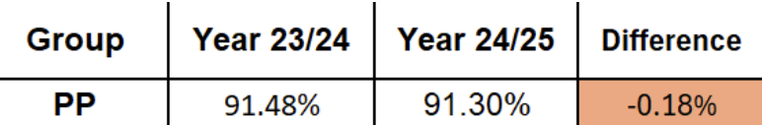  All targeted children’s attendance has improved v last academic year. Successful strategy.
Provision of learning behaviour/family support worker and lead teacher for pastoral to support the emotional well-being of pupils and families. | Successfully supported X PP out of the X PP children through direct work and/or drop-ins. Successful strategy
Free clubs, subsidised trips and visits (non-sports clubs) to increase opportunity and experience and encourage attendance and increase aspiration. (Theatre, Life Bus, visits to school.) | Residential experience for Y2 and Y3 in school and at a residential centre. This was very well received and children benefitted from opportunities to experience outdoor activities that they had not experienced previously. Children also developed self-confidence, risk taking and resilience through being away from their parents. Y3/4 opportunity to sing at De Montfort Hall. Children developed wider appreciation of the world around them through singing opera, and a sense of achievement. Successful strategy

Externally provided programmes
Please include the names of any non-DfE programmes that you used your pupil premium to fund in the previous academic year.
Programme | Provider
The Cabin | Leicester City Council
Foxes Friday | Leicester City Football Club
Pru@Elmsmere | Leicester City Council
The Grove | FSD Academy

Further information (optional)
Use this space to provide any further information about your pupil premium strategy. For example, about your strategy planning, implementation and evaluation, or other activity that you are delivering to support disadvantaged pupils that is not dependent on pupil premium funding.

