

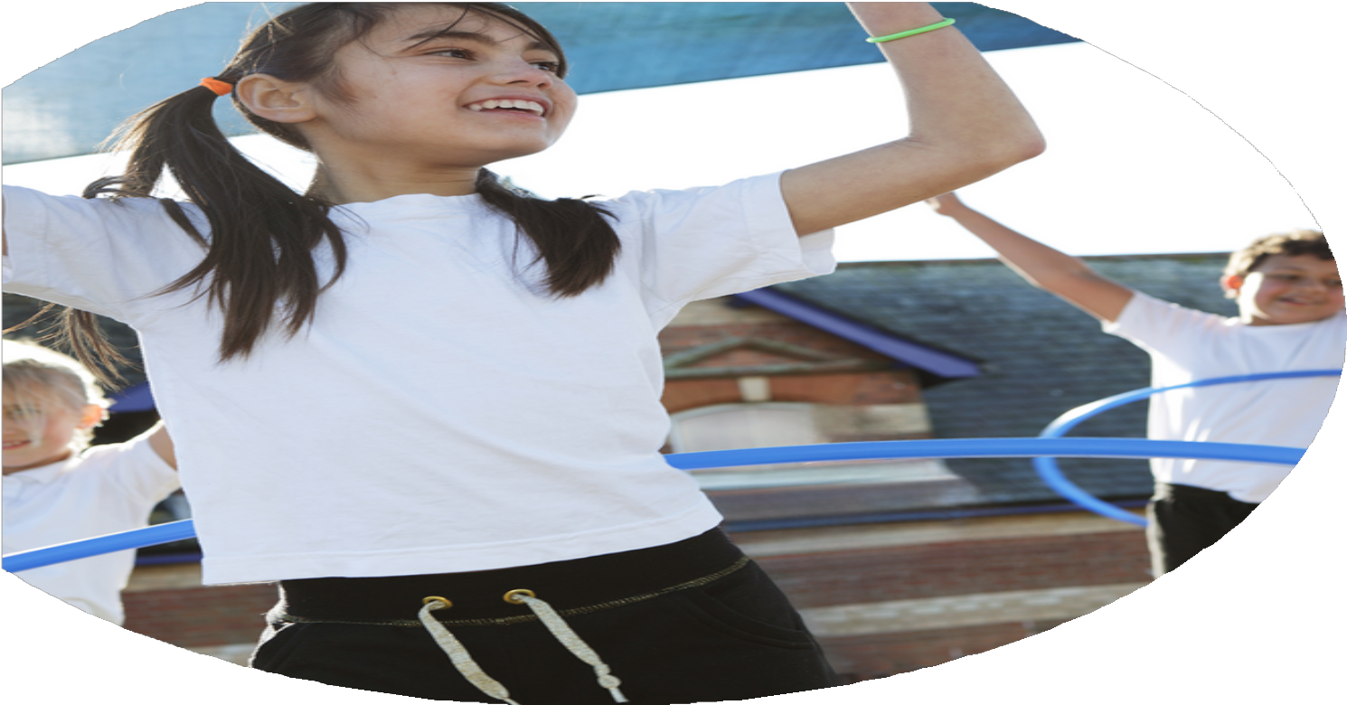
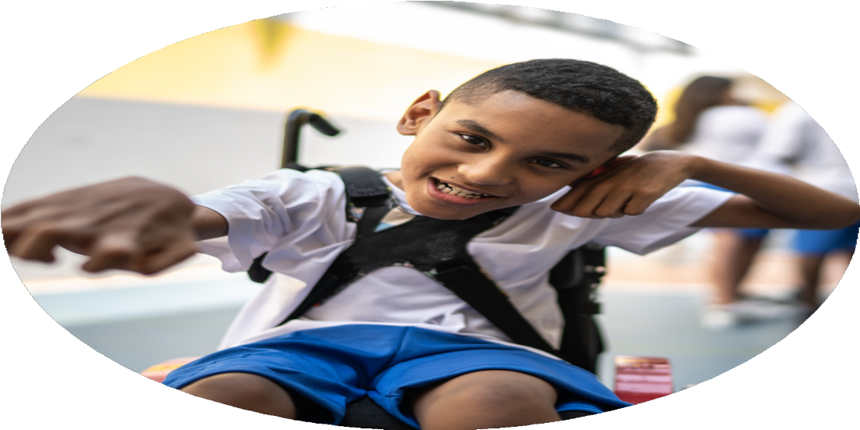




PE Funding

Evaluation Form

Commissioned by

Created by

Images courtesy of Youth Sport Trust

PE Funding Evaluation Form

It is intended that this template should be used as preparation for the completion of the statutory digital reporting tool being introduced this academic year. You can upload data (including swimming) from this template onto this platform once it becomes accessible.
Before you decide how you are going to use the funding for this academic year you should reflect and evaluate the impact of your use of the funding in 2023/24.
All spending of the funding must conform with the terms outlined in the Conditions of Grant document. The template is a working document that you can amend/update during the year.
Based on your evaluation of last year’s funding you should decide what you intend to do this academic year, how you will do it, and what impact you expect it to have.

It is important that the funding is used effectively and based on your school’s needs.
You must use the funding to make additional and sustainable improvements to the PE and sport in your school. You must develop and add to the PESSPA activities that your school already offers.

Summative digital reporting from June 2025 will continue to include swimming and water safety information therefore funding can be used to provide top-up lessons where necessary to ensure pupils meet national curriculum swimming requirements.

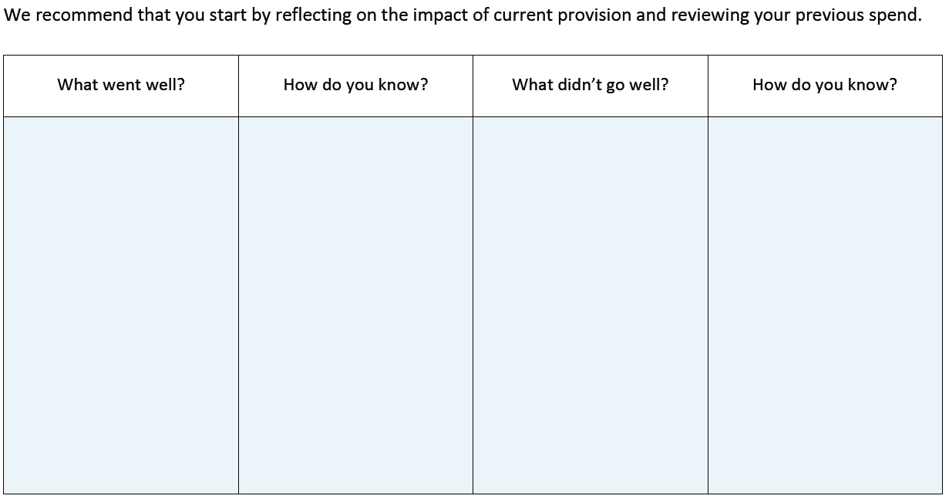
Only 55% of Year 6 pupils could swim 25m and use a range of strokes.

No CPD provided for staff to teach swimming due to local authority policy restrictions.

3 children in the DSP (Designated Specialist Provision) did not attend any external events.

Only 38% of KS1 pupils attended clubs, and 29% attended enrichment events outside school hours.
Swimming attainment below national expectations

Limited swimming CPD for staff

Some pupils still not participating in external events

Lower club and enrichment participation in KS1

100% of pupils across EYFS, KS1, and KS2 attended enrichment events or virtual competitions. 96% of KS2 and 29% of KS1 attended events outside school.

Achievements include Gymnastics County winners (Gold), individual and team medals, and participation in national-level events.

A qualified Level 5 PE coach led PE, successfully since August 2023, and the role was made permanent.

Initiatives such as the Daily Mile, Move It Boom and skipping activities led to increased sustained running ability in pupils and adults.

Targeted programs “This Girl Can,” SEND tennis and Sparks Energy wellbeing club targeted girls, SEND and vulnerable pupils.

CPD and coaching support led to increased confidence and skills among staff in delivering PE.

Year 6 sports leaders led KS1 lunchtime activities, promoting teamwork and responsibility.

Spirit of the Games winners, city-wide awards for Move It March, individual player awards.

High participation in enrichment activities and clubs

Strong competitive performance

Effective leadership and delivery by PE staff

Increased physical activity and engagement

Targeted interventions for specific groups

Improved staff confidence and delivery

Leadership development in pupils

Recognition and awards
What are your plans for 2024/25?

Intent
How are you going to action and achieve these plans?

Implementation
Identify non-swimmers through baseline assessments in autumn; book top-up sessions for summer term; maintain communication with local pools to secure slots; track pupil progress termly. Pool hire and instructor costs for the year: £4280.40

Launch new KS1-focused clubs (e.g., dance, mini games); promote through assemblies and newsletters; gather pupil voice each term to adapt offerings; assign staff or sports leaders to run sessions.

Schedule inclusive in-school events; assign 1:1 support staff where needed; liaise with SENDCo to personalize activities; monitor attendance and engagement through termly reviews.

Deliver leadership training in autumn term; assign Year 5/6 leaders to KS1 lunchtime activities; rotate responsibilities; celebrate contributions in assemblies and newsletters. Inspire together leadership program: £150. Children will work closely with PE lead during lunch times and during sporting events to lead activities. Leaders will then proceed to support sports day for the KS1 children at the end of the year.

Run targeted clubs such as “This Girl Can” and Me in Mind; track participation by demographic; collect feedback from pupils and staff; adjust provision based on engagement levels. Specialized fundamental program: £300, Me in mind: £300, This girl can: £300, Paralympic Legacy Program for DSP: £250, Inspire together KS1 package: £600

Conduct staff audit to identify CPD needs; deliver in-house training led by PE coach and LCFC; provide planning support and model lessons; follow up with peer observations and feedback. CPD to staff from incoming programs such as chance to shine, hockey and DMU dance.

Register for School Games and local leagues in autumn; allocate budget for transport and staffing; track participation and celebrate achievements. Transport costs: £1243.

Continue to embed Daily Mile into lunch times routines; introduce more active play at break and lunch times with the introduction of new equipment.

Contact local authority to explore CPD flexibility; identify online or external CPD options; enroll staff in Level 1 swimming assistant training; review impact through staff feedback. Cost of training for 2 members of staff: £850

Share achievements weekly via newsletters and social media; include PE highlights in celebration assemblies; invite parents to key events. Celebrate the Daily Mile achievements for all KS2 children during weekly assembly. An end the year celebration assembly celebrating sporting achievements.

Renew contract with LCFC to secure coaching provision for 4 days per week; integrate LCFC coaches into curriculum PE and extracurricular clubs; participate in LCFC-led festivals and wellbeing programs. Cost of Primary stars Program for 4 days attendance: £16800. Targeted provision for 3 children, Foxes Fridays: £5400. LCFC will provide CPD to staff

Renew subscription to Inspire Together to access competitions, CPD, wellbeing initiatives, and inclusive programs; schedule staff training and pupil participation in Inspire-led events throughout the year. Inspire together membership cost: £1850. Inspire together football membership and B teams: £575, Inspire together health and wellbeing program: £350 Inspire together Learn to ride provision: £840, Balance ability sessions for EYFS: £600

Enroll staff on a Level 1 Ride leader training course provided by British cycling to provide further engaging enrichment opportunities for the children to ride their bike around the area. Cost of training: £117

Increase swimming attainment to meet national expectations - Embed swimming into the long-term PE curriculum by identifying non-swimmers early, offering annual top-up sessions, and strengthening partnerships with local pools to ensure all pupils meet the 25m requirement and develop water safety skills.

Improve KS1 participation in clubs and enrichment - Develop and promote a wider range of age-appropriate physical activity clubs and enrichment opportunities for KS1 pupils, led by trained staff and sports leaders, to build early engagement and enjoyment in physical activity.

Ensure all DSP and SEND pupils access enrichment opportunities - Plan and deliver inclusive enrichment activities tailored to DSP pupils’ needs, ensuring accessibility, appropriate support, and regular participation in both in-school and external events.

Continue to develop leadership in Year 5/6 pupils - Establish a structured sports leadership program for Year 5/6 pupils, including training, mentoring, and regular opportunities to lead activities, with leadership roles embedded into the school’s ethos and timetable.

Expand inclusive programs for girls, SEND, and vulnerable pupils - Continue and grow targeted initiatives such as “This Girl Can,” SEND tennis, and wellbeing clubs to ensure equitable access to physical activity, with a focus on building confidence, participation, and enjoyment.

Enhance staff confidence and delivery in PE - Provide ongoing CPD, peer mentoring, and access to high-quality resources to support all staff in delivering engaging and inclusive PE lessons, reducing reliance on external providers and building internal expertise. LCFC to support CPD provision

Maintain high levels of competitive sport participation - Sustain and expand participation in local and regional competitions by maintaining strong links with School Games and community sports organizations, ensuring pupils have regular opportunities to compete. Ensure that there is an adequate budget for transport cost for events.

Increase daily physical activity across the school - Embed structured physical activity into the school day through initiatives like the Daily Mile, active breaks, and playground activities, encouraging all pupils to meet the 60-minute in-school activity target.

Improve swimming CPD access for staff - Explore flexible CPD options for staff to improve their understanding of swimming and water safety, despite local authority restrictions, to better support pupil progress and confidence in the water.

Celebrate and communicate PE success across the school community - Promote a culture of celebration by regularly sharing PE achievements through assemblies, displays, newsletters, and social media, engaging families and raising the profile of sport and physical activity across the school.

Continue membership with Active Inspire (Inspire Together) - Renew subscription to Inspire Together to access a wide range of competitions, CPD, wellbeing initiatives, and inclusive programs that support whole-school physical activity and staff development.

Continue membership with LCFC (Leicester City Football Club) - Maintain partnership with LCFC to access high-quality coaching, curriculum support, and enrichment opportunities, including football festivals and health and wellbeing programs.

CPD cycling opportunities - Provide Ride leader training to staff to support with providing enrichment opportunities to the school community

What impact/intended impact/sustainability are you
expecting?
How will you know? What evidence do you have or
expect to have?
Swimming assessment records showing increased 12% of pupils meeting 25m and stroke requirements; comparison with previous year’s data. 67% of children who attended swimming passed there 25 meters

53% of children in KS1 have attended an external events showing an increase of 24% on previous years data in 2023

Club registers, enrichment attendance logs, have shown a current attendance of 65% of children have attended a morning or after school club. This is an increase of 21% based the previous year

Participation tracking for enrichment and events documented, increased engagement of all children in DSP of external and internal competitions.
Pupil reflections, staff feedback, increased pupil confidence and responsibility in leading activities - young leaders from year 5 worked with the PE Lead over the course of the year and supported KS1 and KS2 children during their break time. The leaders Led and supported the KS1 sports day. The leaders had the opportunity to attend at a local school in the area and support children during their activities.

Gender-based participation data; feedback from targeted programs like “This Girl Can” and “Disney shooting stars”; improved confidence and enjoyment reported in pupil feedback. An increase of Girls activities during break times chosen by the children for them.

Competition results, team participation logs, awards and recognitions, increased number of pupils involved in competitive sport

Activity tracking tools (e.g., Daily Mile logs), teacher observations, improved fitness and stamina in pupils, increase success in Competitions.

Permanent PE coach role, embedded programs, staff CPD, consistent funding allocation, whole-school culture of physical activity

Newsletters, social media posts, parent engagement, increased pupil pride and motivation
Improved swimming attainment across Year 6 - Embedding swimming into the long-term PE curriculum with annual top-up sessions; building strong partnerships with local pools; ensuring early identification of non-swimmers for targeted support.

Greater KS1 engagement in physical activity - Establishing a culture of active lunchtimes and age-appropriate clubs led by trained staff and sports leaders; creating a bank of resources and routines that can be reused annually.

Increased inclusion for DSP and SEND pupils - Developing a consistent program of inclusive events and activities; training staff in adaptive PE strategies; embedding inclusive practices into whole-school planning.

Sustained leadership development in Year 5/6 - Creating a yearly cycle of sports leader recruitment and training; embedding leadership roles into the school’s ethos and timetable; mentoring from older pupils to younger ones.

Higher engagement from girls and vulnerable groups - Normalizing participation through consistent, visible role models and inclusive clubs; maintaining targeted programs like “This Girl Can” and Disney shooting stars as part of the annual offer.

Improved staff confidence and quality of PE delivery - Building internal capacity through CPD and peer mentoring; developing a PE curriculum and resource bank that supports non-specialist teachers; reducing reliance on external providers.

Continued success in competitive sports - Establishing strong links with local competitions and School Games; maintaining a calendar of events and training; developing pupil interest and skills from early years onward.

Increased daily physical activity across all pupils - Embedding active routines like Daily Mile and active breaks into the school day; training staff to lead and sustain these independently; promoting a whole-school active ethos.

Improved physical literacy in EYFS and KS1 - Integrating fundamental movement skills into the EYFS curriculum; training staff to deliver high-quality early years PE; using consistent assessment tools to track progress.

Long-term sustainability of PE provision - Securing a permanent PE lead role; embedding PE and physical activity into the school development plan; ensuring budget allocation for key programs and CPD.

Enhanced visibility and celebration of PE - Creating a culture of celebration through regular assemblies, displays, and newsletters; involving parents and the wider community; maintaining a strong PE presence in school communications.

What impact/sustainability have you seen?
What evidence do you have?
Swimming assessment records, top-up session registers, pupil progress tracking sheets - Swimming assessment records showing increased 12% of pupils meeting 25m and stroke requirements; comparison with previous year’s data. 67% of children who attended swimming passed there 25 meters
100% of the children who attend swimming lessons through the school have learnt water safety, this includes -
Safe entries and exits: Learning how to get in and out of the water safely.
Floating and treading water: Basic survival skills.
Recognizing water hazards: Understanding potential dangers in different water environments.
Emergency responses: Knowing how to signal for help and what to do in an emergency

Sporting achievements - Virtual Events Summary
- Football: Achieved 46 awards out of 59 across KS1 and KS2.
- Athletics: Overall winners in all year groups, with 12 first-place winners. Additionally, 8 children from Year 3-6 qualified for county competitions.
- Move It Boom: Secured 2nd place.
- Staff Steptober: Achieved over 5 million steps, winning first place in the city.
- Basketball: Overall winners with 8 first-place winners throughout KS2.
- Let Girls Play Competition: 3 children's sports artworks represented at the county level.
- Move It March: Winners, logging 104,543 minutes of activities.
- Most Active Girl: A Year 5 girl won the title of the most active girl in the city.

Sporting achievements - Events Summary
- Rice Bowl Football Competition: Won the first round and qualified for the second round.
- Boys Football: Finished second in the football league.
- Girls Football: Finished first in the football league, represented the county at Holmes Park, and achieved 3rd place.
- Cross Country: 44 children participated, all placing 77th or below, with 23 placing below 30th. 20 children qualified for the finals at Mallory Park, with 8 receiving medals. Out of the 20, 10 represented the county, and 3 placed 2nd and 3rd.
- Gymnastics: Four teams competed in the Gymnastic Rise competition. Two teams secured first place, one finished third, and one placed fourth. Individual awards included 2 first places, 2 second places, and 1 third place. The two first-place teams qualified for the county finals, placing 2nd and 4th.
- Outdoor Athletics: Achieved various 1st, 2nd, and 3rd place awards. The Year 4 team qualified for the Quad Kids event, winning 1st place in the city and 3rd in the county finals, along with the Spirit of the Games award.
- Spirit of the games award: Stokes Wood also received the Spirit of the Games award for the year.
100% of children in the school took part in a sporting event

Daily Mile success - Our Daily Mile initiative has been a great success, earning Stokes Wood the Daily Mile Fit for Life Award.
There has been a significant increase in Year 6 children completing 1,000 laps throughout the year, with rewards presented in assembly. Weekly presentations celebrate participation and all successes, fostering a culture of fitness and achievement within the school.

Our leadership provision has been instrumental in supporting various activities. They played a key role in organizing and managing Sports Day, ensuring everything ran smoothly. Additionally, they visited local schools and participated in leader-led activities with children, promoting teamwork and leadership skills among the students.

Club registers demonstrate increased participation in after-school clubs among KS1 pupils. Pupil voice reflects improved confidence and enthusiasm for physical activity, while teacher observations note more consistent engagement in both structured and unstructured physical activity throughout the year.

Participation logs show a rise in the involvement of SEND pupils in enrichment and competitive events. Staff feedback highlights improved confidence in adapting PE lessons to meet diverse needs, and pupil feedback indicates greater enjoyment and a stronger sense of inclusion in PE sessions.

Newsletters, assemblies regularly celebrate PE achievements. Social media posts and school website updates highlight pupil success. Feedback from pupils and parents shows increased pride and motivation linked to the visibility of PE within the school community.

Improved swimming attainment across Year 6 - Increased percentage of pupils achieving 25m and demonstrating stroke variety; earlier identification of non-swimmers leading to more targeted support and fewer pupils needing top-up sessions in Year 6.

Greater KS1 engagement in physical activity - Higher participation in morning and after-school clubs; improved physical confidence and enthusiasm for activity among younger children more consistent engagement across the year.

Increased inclusion for DSP and SEND pupils - More SEND children participating in enrichment and competitive events; increased confidence and enjoyment in PE; staff more confident in adapting activities to meet diverse needs.

Sustained leadership development in Year 5/6 - Pupils showing improved leadership, communication, and responsibility

Higher engagement from girls and vulnerable groups - More girls and vulnerable pupils regularly attending clubs and events

Improved staff confidence and quality of PE delivery - Staff independently delivering high-quality PE; broader activity range

Continued success in competitive sports - Consistent representation and success in competitions; increased pupil involvement

Increased daily physical activity across all pupils - Pupils more active throughout the day, improved stamina and focus

Improved physical literacy in EYFS and KS1 - Stronger movement skills; smoother transition into KS2 PE

Long-term sustainability of PE provision -PE lead role embedded, consistent planning and funding

Enhanced visibility and celebration of PE - PE achievements regularly celebrated, increased motivation and pride

